IBM Db2 Bridge: End to End Schema Conversion and Data Migration from Netezza to Db2
By: Sakshi Khokhar and Sairaman K
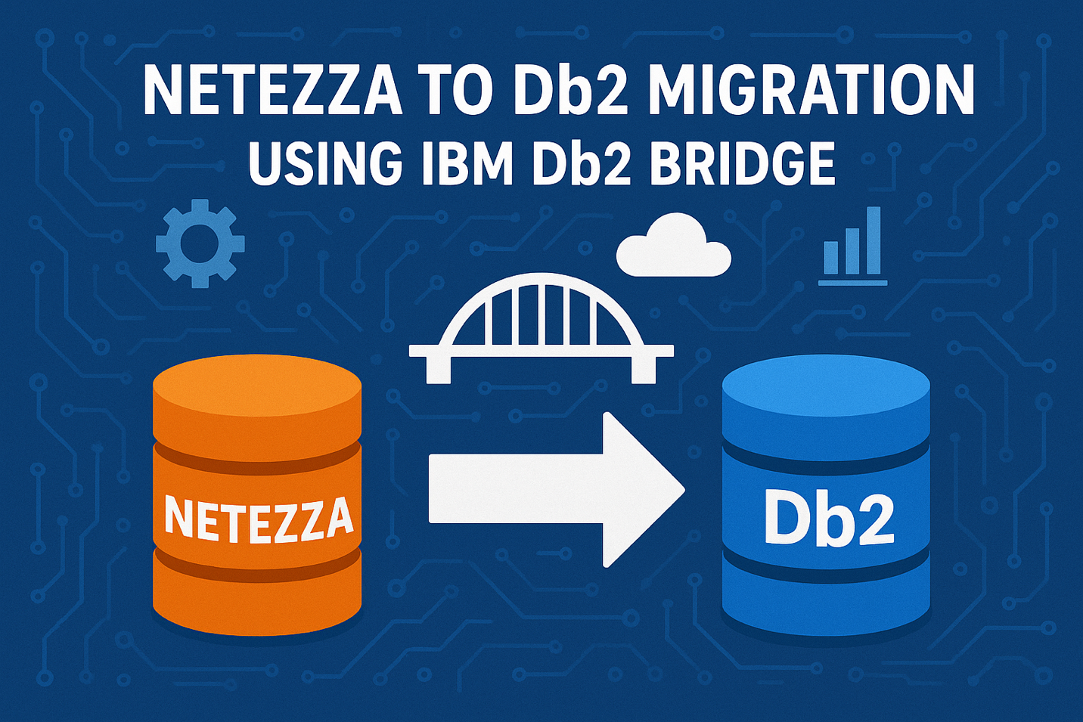
Introduction:
In today’s data-driven enterprises, migrating workloads across platforms has become a strategic imperative, whether it is for infrastructure modernization, cloud adoption or performance optimization. However, data migration is rarely straightforward. It often involves challenges such as schema mismatches, dependency issues and performance risks.
This post explores how IBM Db2 Bridge enables seamless, end-to-end schema conversion and data migration from Netezza to Db2, ensuring efficiency, integrity and minimal disruption throughout the process. It leverages automated DDL conversion and high-speed data streaming to simplify complex migrations. With built-in logging and compatibility checks, it helps to achieve transparency and error-free execution for enterprise workloads.
What is IBM Db2 Bridge?
IBM Db2 Bridge is a robust data movement tool designed to support a wide range of enterprise migration scenarios. Whether you're upgrading hardware, shifting operating systems or adopting cloud-native environments, Db2 Bridge simplifies the process by leveraging ODBC connectivity, making it platform-agnostic and highly adaptable.
The tool offers several standout features, including support for diverse workloads-both transactional and analytical across on-premises and cloud deployments. It operates seamlessly across different operating systems and hardware architectures, ensuring smooth migrations while maintaining data integrity.
Db2 Bridge integrates effortlessly into IBM’s data ecosystem, acting as a bridge between legacy systems and modern Db2 deployments. This enables organizations to modernize their infrastructure without rewriting applications or compromising data fidelity.

Migration Use Case: Netezza to Db2:
Db2 Bridge offers another great capability for data movement from Netezza to Db2 database which not only caters to the diverse range of use case scenarios but also offers a smooth and uninterrupted schema conversion and data migration. Some of the key features are discussed below:
- Efficient Extraction and Conversion: Db2 Bridge automates the extraction of DDLs from Netezza and converts them into Db2-compatible formats with precision. By ensuring schema alignment before migration, it minimizes manual intervention and accelerates the overall process.

- Compatibility Checks: Before initiating data movement, Db2 Bridge performs thorough compatibility checks between source and target environments. The source table constraints and target table constraints are properly enforced before unloading and loading of data respectively. This proactive approach prevents migration errors and guarantees that the target schema adheres to the required rules.

- Logging & Monitoring: Db2 Bridge offers robust logging and monitoring capabilities throughout the migration lifecycle. Detailed logs capture every step, from schema conversion to data loading, enabling easy troubleshooting, thus providing visibility to progress, error alerts and ensuring transparency.
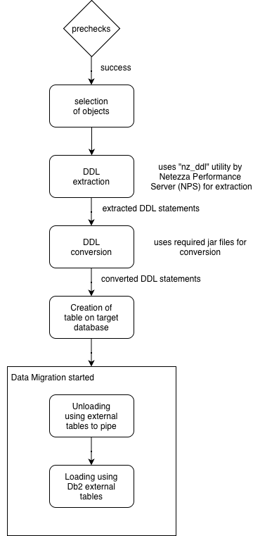
Figure 1: Netezza to Db2 Migration flow
End to End Schema Conversion:
Migrating from Netezza to Db2 involves more than just moving data. It requires a comprehensive schema conversion to ensure structural compatibility and application continuity. Steps included in the schema conversion process are discussed below:
- Schema Discovery: Db2 Bridge auto-discovers the source schema using ODBC connectivity handling the schema elements efficiently.

- Object Selection: Db2 Bridge provides flexibility in choosing what to migrate. Users can opt for an entire database when performing large-scale migrations or select specific tables for targeted transfers.

- DDL Extraction: This involves the use of “nz_ddl” utility which is part of Netezza Performance Server (NPS) to perform the DDL extraction for the specified tables.

- DDL Conversion: The input file containing the extracted DDL is then used by the required jar files to convert Netezza DDLs to Db2 compatible format.

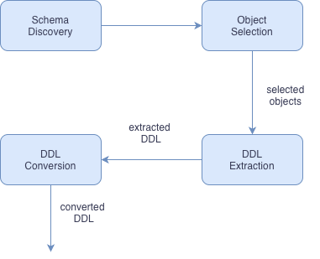

Figure 2: End to End Schema Conversion

Data Migration Workflow:
Once the compatibility checks are done, the table is created on the target database. After another round of enforcing target table constraints which includes the successful and compatible creation of table on target database, the data migration is triggered which prominently includes the following steps:
- Object creation: After schema compatibility checks and successful DDL conversion, Db2 Bridge creates the target tables in Db2. This step ensures that the tables from the source schema are accurately replicated in the target environment, maintaining structural integrity.

- Data Unloading: Data from Netezza is extracted using external tables and streamed through Linux pipes. This approach minimizes intermediate storage requirements and accelerates data movement, making it ideal for handling large datasets efficiently.

  - Text-delimited format for migration: During migration, Db2 Bridge uses Netezza external tables to unload data in text-delimited format, ensuring compatibility with Db2 loading processes. Fixed-length formats are avoided to maintain consistency.

  - SQL-driven extraction for automation: The unload step leverages SQL commands like “INSERT INTO external_table SELECT * FROM source_table”, enabling Db2 Bridge to automate ETL without additional tools.

  - Remote streaming for efficiency: By using REMOTESOURCE options (ODBC/JDBC), Db2 Bridge can stream data directly from Netezza to the target environment through Linux pipes, reducing intermediate storage and speeding up migration.

- Data Loading: The unloaded data is ingested into Db2 using the Db2 External Tables command. This method supports parallel loading, ensuring high throughput and reducing migration time, even for multi-terabyte workloads.

  - Target table creation for external load: After schema conversion, Db2 Bridge uses Db2’s external table loading mechanism to ingest data from the unloaded files into Db2 tables, maintaining structural integrity.

  - Flexible field and encoding options: Db2 Bridge configures options like DELIMITER, ENCODING and ESCAPECHAR during load to match the source file format from Netezza, ensuring smooth ingestion.

  - Character set alignment for consistency: For mixed or Unicode data, Db2 Bridge enforces encoding settings (e.g., UTF-8) during load, validating character sets to prevent corruption.

- Comprehensive Tracking: Throughout the migration, Db2 Bridge provides detailed logs and real-time monitoring dashboards. These tools help administrators track progress, validate row counts and quickly troubleshoot any issues that arise during the process.

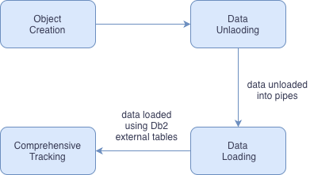

Figure 2: Data Migration Workflow

Conclusion:
IBM Db2 Bridge is more than a migration tool. It s a modernization enabler. With advanced features like automated schema discovery, intelligent DDL conversion via jar files and high-speed data transfer using Linux pipes, it transforms the complex Netezza-to-Db2 migration into a streamlined, error-free process. Real-time logging, compatibility validation and cloud-ready architecture ensure scalability and resilience for enterprises moving toward hybrid and AI-driven environments. By combining automation with performance optimization, Db2 Bridge delivers a future-proof solution for organizations seeking agility and innovation.

About the authors:
Sakshi Khokhar is a Software Developer at IBM India Software Lab, with experience of working with databases and cloud technologies. She holds a Bachelor’s in Information Technology from the Indian Institute of Information Technology, Allahabad. Sakshi can be reached at Sakshi.Khokhar1@ibm.com
Sairaman K is a Software Developer and technical lead for IBM Db2 Bridge at the IBM India Software Lab, with over 6 years of experience in Databases, Kubernetes and Cloud services. He holds a Bachelor’s in Computer Science from the Thiagarajar college of Engineering, Madurai. Sairaman can be reached at sairamank@in.ibm.com

